| **Date** | **Author** | **State / changes** |
| --- | --- | --- |
| 23/09/2010 | Shpileuskaya C. | Created |
|  |  |  |

Search word combinations:

|  |
| --- |
| environment |
| global warming |
| green office |
| Car-Free Day |

In an underdeveloped country, don't drink the water; in a developed country, don't breathe the air.

# Help the world go green

|  |  |
| --- | --- |
|  | **Many years from now people were trying hard to spread first automobiles all over the world, they were glorifying numerous advantages of having a car. Times have changes and today newspapers and magazines claim that cars have more cons than pros. They pollute the environment, they contribute to global warming, they deprive people from physical activity and they move us away from nature. More and more people dedicate all their efforts to banish cars from big cities.** |

Unfortunately, people tend to learn by their own mistakes. And now, when the ozone layer is considerably damaged, the ocean level has risen and earthquakes are shaking the planet, we start doubting, may be it is *our* fault. But these signs are still not enough for us, we keep on ruining our environment. We build unreliable drilling rigs, we erect nuclear power plants, cut down rainforests and grow genetically modified crops.

But sometimes we do look ahead. And when we do it, we get terrified and we try to do something to smooth over the consequences of our dangerous experiments. Are these short glimpses enough to save our planet from ourselves? You know whom it depends on. More and more people understand that. And they undertake first modest steps to improve the situation.

Our country is not an exception. This year Belarus took part in the World Car-Free Day for the third time. There are more that 3.5 million cars in the republic and the number is constantly growing. We can only imagine the amount of CO2 all these cars emit daily into the atmosphere. No doubt, people who decided to support the green movement and gave a day off for their cars were in the minority. But still the number of cars that remained on the parking lot on this day exceeded the number of the previous year. This time city authorities created all necessary conditions to encourage car owners to give up their automobiles for one day. Minsk public transport was free for people who had their vehicle registration certificate on them. And even the weather was pretty good to undertake a walk.

Our company eagerly supported the movement. Undoubtedly, not everyone was ready to use their legs according to the intended purpose. But still I’m happy with the result. Actually our company supports the green movement on the regular basis because the majority of our team members daily get to work by bus, on foot or ride a bicycle. And on September 22nd many of our car owners left their vehicles at home and stepped on their way to green office.

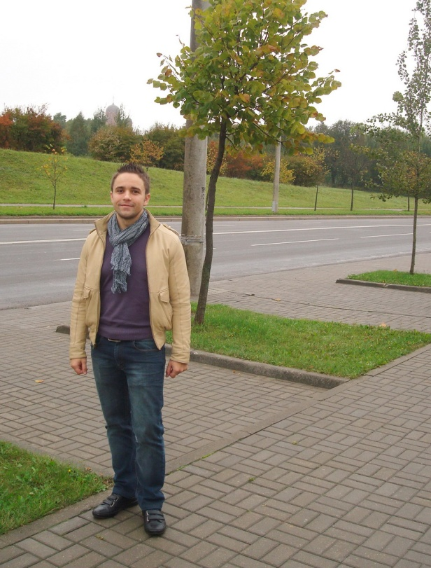 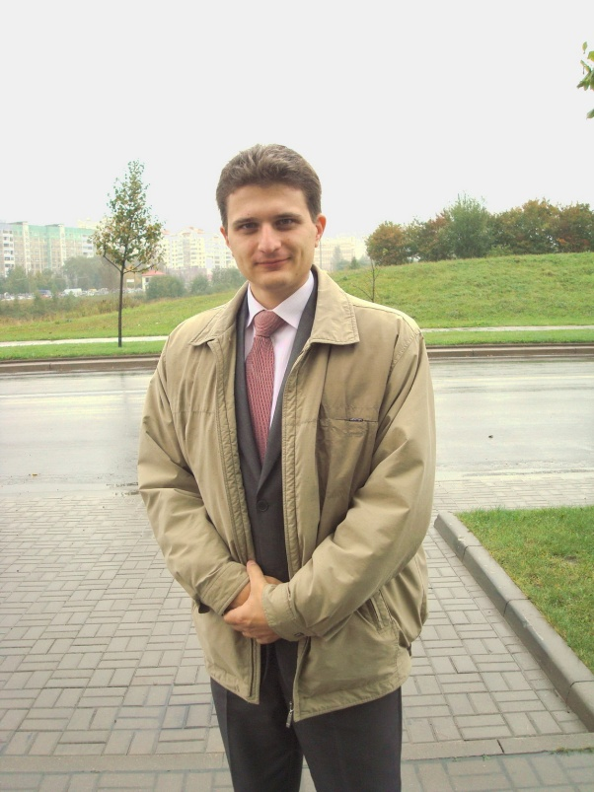

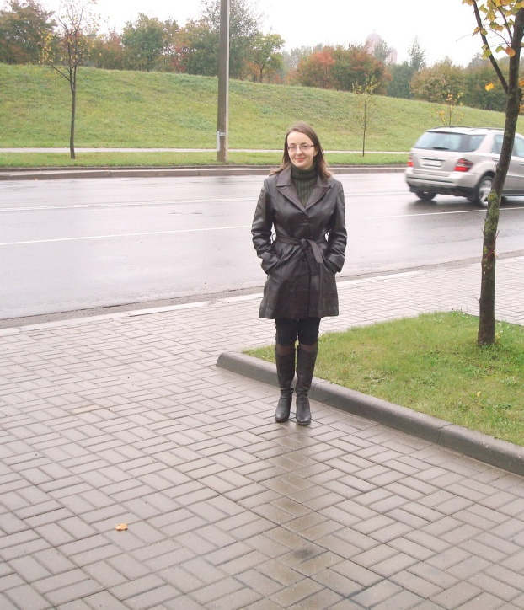 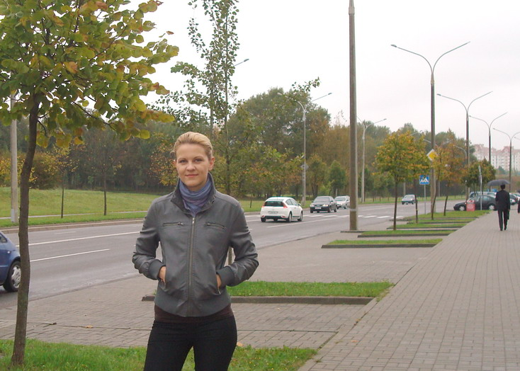

So the parking lot in front of Gersis Software building missed half of the usual residents. And this time I prefer to think that it was half empty and not half full!

P.S. Every time I see an adult on a bicycle, I no longer despair for the future of the human race.  H.G. Wells